Group 4

Project Proposal

***Project Theme*:** To represent the impact average global temperature has on artic sea ice and global sea levels

***Reasoning*:** Our initial search began on the NASA website. We wanted to capture data from satellites in order to create a story from space. Eventually we decided upon telling the story of climate change through measurements of global temperature, artic sea ice, and sea levels.

***Links*:**

[**https://sealevel.nasa.gov/data**](https://sealevel.nasa.gov/data)(Sea/Ice Levels)

<http://berkeleyearth.org/data-new/> (Global Temp.)

<https://nsidc.org/data/sipn/data-sets.html> (Ice Levels)

(Metadata)

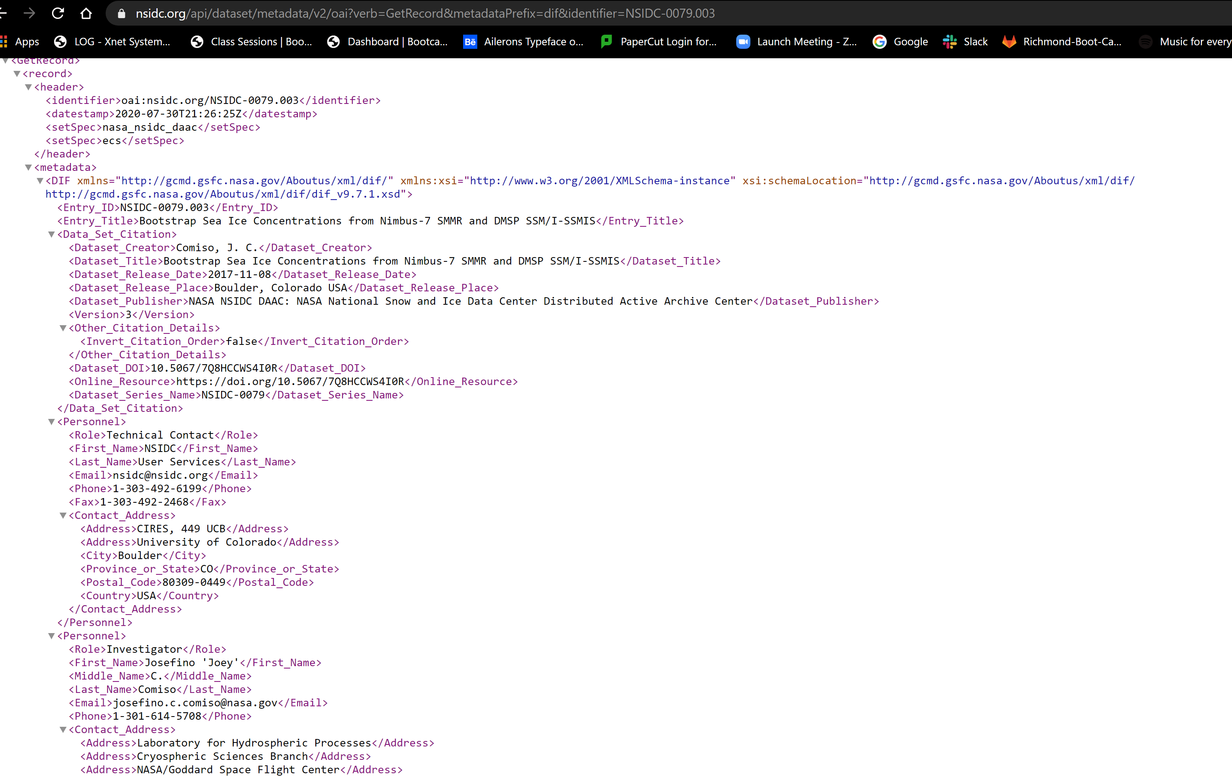

<http://psc.apl.washington.edu/zhang/Global_seaice/> (Ice Levels)

***Relevant Visualizations*:**

(Sea Levels)

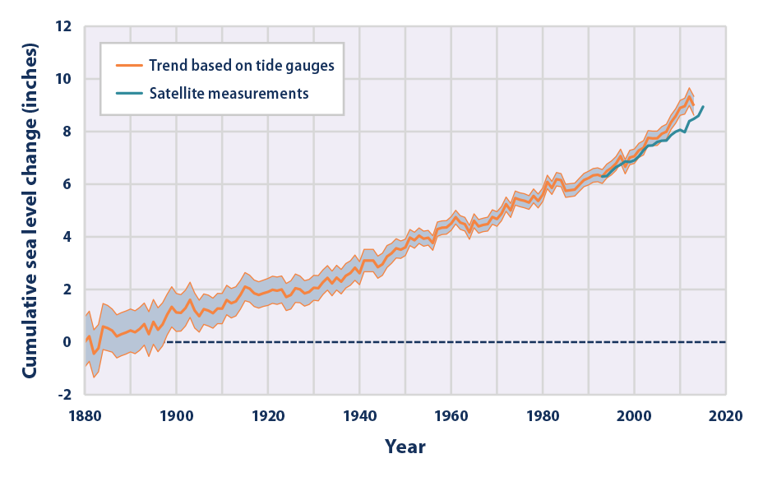

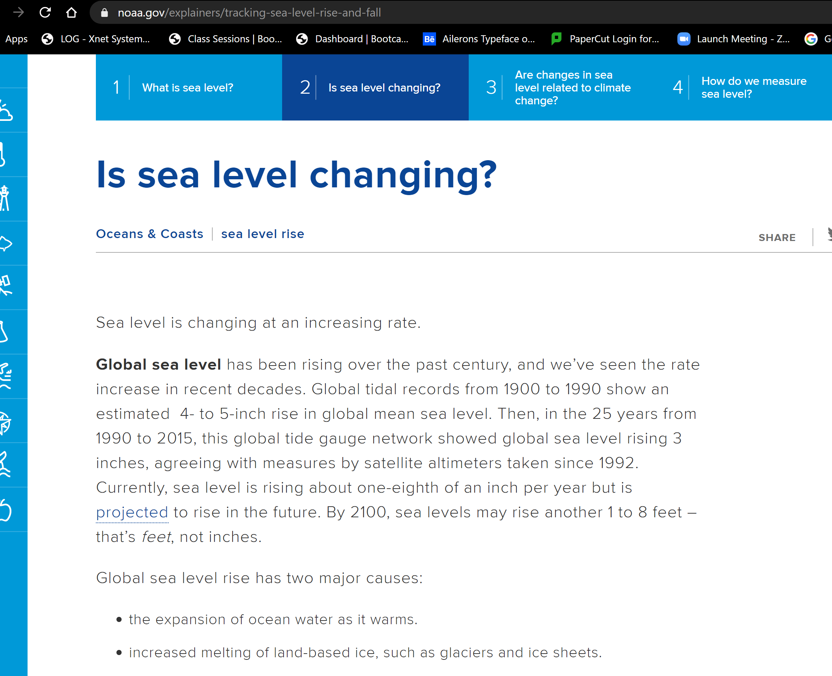

(Ice Levels)

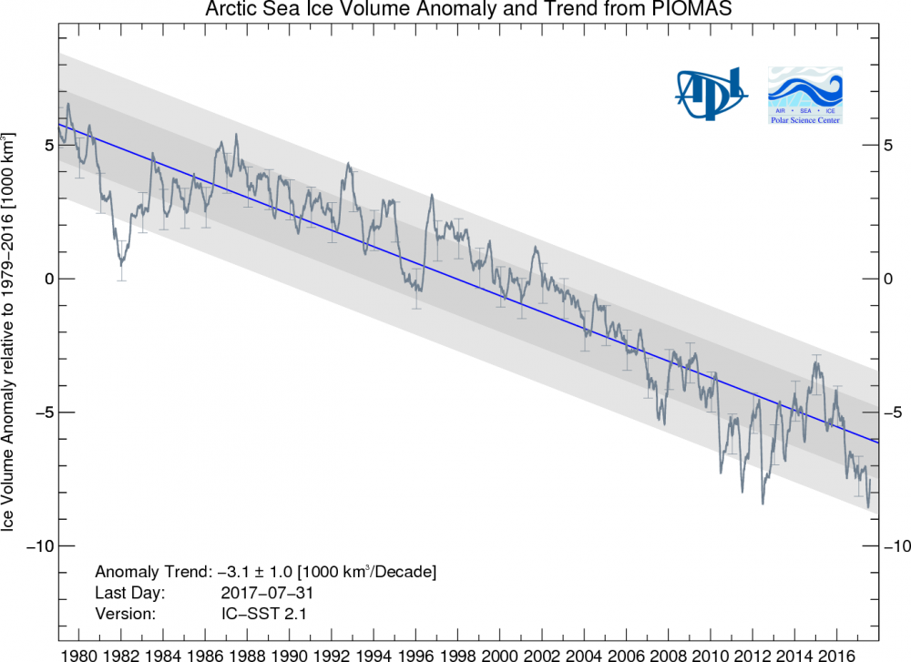

(Global Temp.)

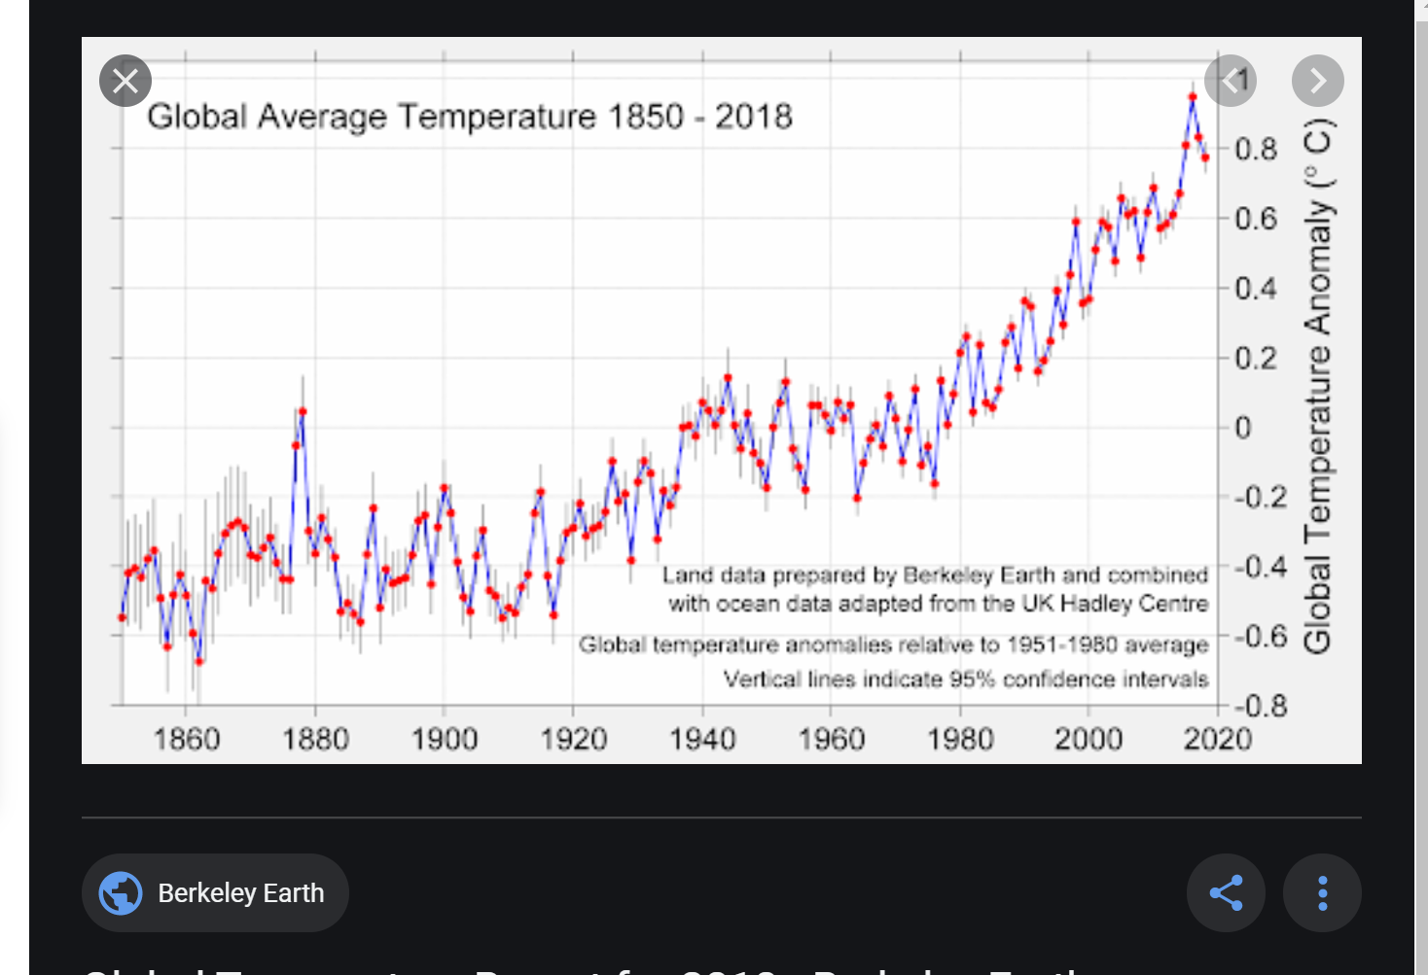

***Project Format*:**

We’ve decided to use a one page dashboard to display our project. All info would be accessible through a dropdown menu. If needed, we can branch out to multiple pages. Our dashboard will include images and plots for sea level changes, artic sea ice changes, and for global temperature. It will also include a project overview and conclusion.